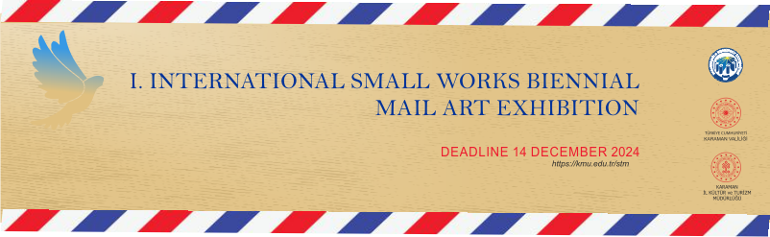

**KARAMANOĞLU MEHMETBEY UNIVERSITY**

**ART DESIGN AND ARCHITECTURE FACULTY**

**WORK PARTICIPATION FORM**

- The subject is free.

- It is open to all branches of plastic arts.

- In plastic works, the longest side of the work should not exceed 60 cm.

- There should be no breakable glass or frames in the works..

Please fill in the following fields and send this form to one of the addresses ‘kmustsergi@gmail.com - iswb@kmu.edu.tr’ immediately.

**Participant's**

Name Surname :

Title :

Institution :

Address :

E-mail Address :

Phone :

Name of the Work :

Dimensions :

Technique :

|  |
| --- |
|  |

Artist Image :

Work Image :

|  |
| --- |
|  |