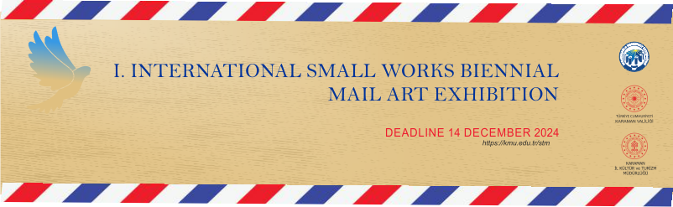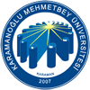

**KARAMANOĞLU MEHMETBEY ÜNİVERSİTESİ**

**SANAT, TASARIM VE MİMARLIK FAKÜLTESİ**

**Dear**

Our Selection Committee invites you to the “send for peace” event which will be held on 20-27 December within the scope of “I. INTERNATIONAL SMALL WORKS BIENNIAL /MAİL ART EXHIBITION” to be held in Karaman between December 2024 - August 2025.

We would be honored to see you among us with your selected work(s).

Until 14 December 2024, we wish you to send your work(s) to the Dean's Office of the Faculty of Art, Design and Architecture of our University Yunus Emre Campus and the attached form to one of the addresses ‘kmustsergi@gmail.com - iswb@kmu.edu.tr’ and thank you.



**Dr. Öğr. Ü. Ahmet Hakan YILMAZ**

**Küratör**